DEPARTMENT OF **MECHANICAL**



# ENGINEERING

**Elementary**

I studied in Agutayan Elementary School from year 2009 to 2015. I started my formal education like most students, with elementary school serving as the foundation for my learning. It was here that I gained my first insights into subjects like mathematics, science, and arts.

**Achievements:**

* Graduated as class Valedictorian.
* Academic award of excellence
* Consistent honor student from grade 1-6
* Elected as SSG president and Class president

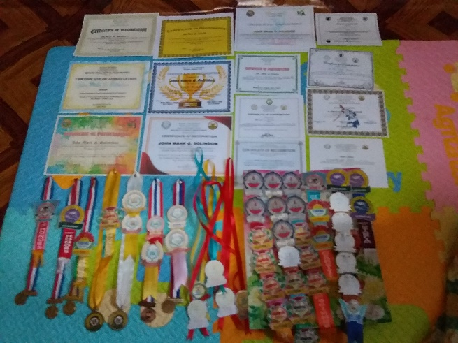

**Experiences:**

* Compete in science and math competitions
* School representative for poster making contest
* SSG president
* Class president

|  |
| --- |
|  |